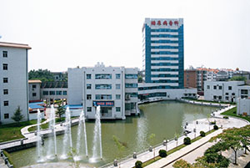
Tianjin Medical University Metabolic Disease Hospital, also named Tianjin Metabolic Diseases Treatment and Prevention Center, is a Sino-Japanese cooperative program. It was founded in July, 1998 and is affiliated to Tianjin Medical University. The major medical facilities are provided by the Japanese government for free (approximately 504,000,000 JPY). In addition, the Tianjin municipal government has invested approximately 40,000,000 RMB in infrastructure construction. The hospital occupies an area of 7,200 square meters, and the total construction area is 12,000 square meters with 12 floors and 188 beds in the main building. The daily out-patient visits reach around 2,500. It is the first general specialized hospital for the treatment and prevention of diabetes and its complications.
Metabolic Disease Hospital has developed into a large highly specialized hospital with integrated treatment, research, and teaching. The hospital has 283 staff, among whom 28 hold PhD degrees, and 66 hold master degrees. The hospital has 48 associates and full professors and specialists, 8 PhD supervisors and 14 Master’s student supervisors. The hospital is not only in charge of undergraduate teaching courses of Medical Laboratory School and Biomedical Engineering School, but also the clinical internship tasks of School of Public Health, School of Medical Laboratory and School of Biomedical Engineering. Metabolic Disease Hospital has the Tianjin Institute of Endocrinology, which is the earliest institute of endocrinology founded in China.
Endocrinology and Metabolic Diseases of hospital is a national key subject, and the hospital has also the Key Lab of Hormone and Development of the Ministry of Health.
Dr. Baba Shigeaki, former vice president of the International Diabetes Union, a diabetes specialist of Japan, and Zhisheng Chi, former Chairman of the China Diabetes Committee and a professor of Peking Union Hospital are honorary presidents of the hospital. Presently Professor Liming Chen is the president and director of the institute of endocrinology.
Metabolic Disease Hospital aims at the treatment of diabetes I and diabetes II, vascular pathological diseases, and neurological pathological diseases caused by diabetes.

