The 2nd China and India Yoga Summit Held on Campus

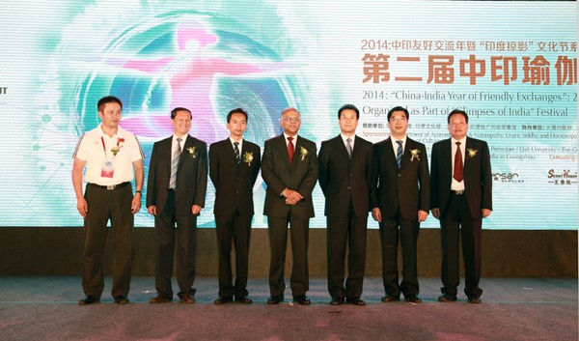
On July 7, 2014, the Opening Ceremony of the 2nd China and India Yoga Summit was held on the Old Town Campus of Dali University. The event lasted from July 7 to July 12. More than 2,000 practioners from all over the world participated in the event. The event was graced by renowned Yoga Masters including Dr. Geeta Iyenger from Iyengar School, Pune and Dr. H. R. Nagendra, Chancellor, Swami Vivekananda Anusandhana Samsthana, Bangalore including prominent teachers like Joseph H Pereira, Birjoo H. Mehta , Abhijata Sridhar , Deepika Mehta , and some more taught and practiced with the fans and practioners.
H.E. Mr. Ashok K. Kantha, the Ambassador of India to China, H.E. Mr. Gao Shusheng,Vice Governnor of Yunnan Province, Mr. Liang Zhimin, Party Secretory of Dali CPC and Mr. He Hua, Governor of Dali Prefecture, along the Prof. Yang Rongxin, President of Dali University were at the Ceremony.
The Summit is one of the events of 2014 China-India Year of Friendly Exchanges. At the Ceremony, H.E. Mr. Gao Shusheng expressed his warm congratulations and best wishes for the success of the event. H.E. Mr. Ashok K. Kantha said that as a year of friendly exchanges, many India functions are held in various of Chinese cities and he asserted that the cultural exchanges will facilitate the relation between India and China.

