Library
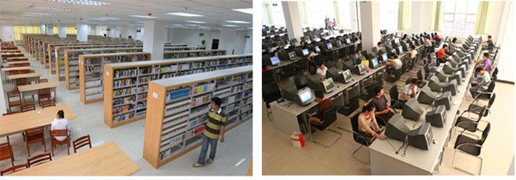
Until 1995 the library contained more than 408,000 books; due to the rapid development in the field of student recruitment, the university built a new modernized library covers 15000 square meters which currently, has over 1.2 million books (including 200,000 books in English), 1,300 different periodicals and journals in Chinese and other languages.
Ten different kinds of book-databases have been introduced and the database is also connected with Partners Harvard Medical International’s library database. The library currently contains seating for 1500 readers in the readers area and more than 350 seats in the electronic library access area.
