Partner Institutions

Russia
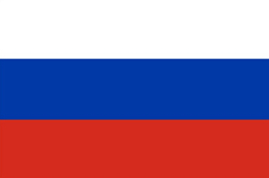
Rostov State University of Civil Engineering
http://www.rgsu.ru/
The Moscow State Automobile& Road Technical University
http://www.madi.ru/
Russian State Geological Prospecting University
http://www.rsgpu.ru/
Saint Petersburg State Polytechnical University
http://www.spbstu.ru/
Ural Federal University
http://urfu.ru/en/
Holland
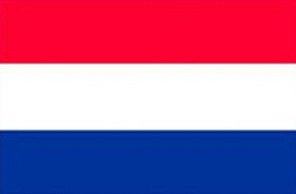
University of Twente
http://www.utwente.nl/en/

France
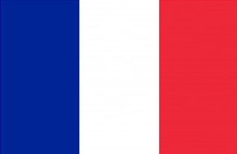
University of Burgundy
http://en.u-bourgogne.fr/

the United Kingdom
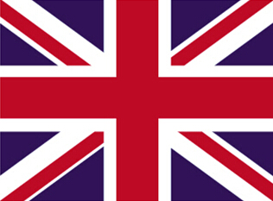
The University of Nottingham
http://www.nottingham.ac.uk/
Coventry University
http://www.coventry.ac.uk/
University of Leicester
http://www.le.ac.uk/
Ireland
University College Dublin
http://www.ucd.ie/
Kazakhstan
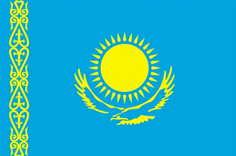
Al-Farabi Kazakh National University
http://www.kaznu.kz/

Korea
Chonbuk National University
http://www.cbnu.edu/main/main.php
Kumoh National Institute of Technology
http://www.kumoh.ac.kr/main.do
Inha University
http://www.inha.ac.kr/
Korea Maritime and Ocean University
http://www.kmou.ac.kr/2013/main/index.jsp
Cheju National University
http://www.jejunu.ac.kr/_2014/main.jsp
Hanyang University
http://www.hanyang.ac.kr/
Korea Maritime Institute
http://www.kmi.re.kr/kmi/en/
Pukyong National University
http://www.pknu.ac.kr/usrEngIndex.do
Ajou University
http://www.ajou.ac.kr/en/
The Transport Institute
http://english.koti.re.kr/

South Africa
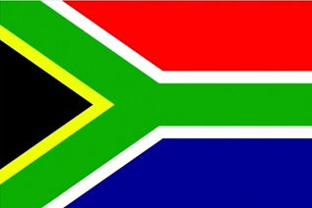
Tshwane University of Technology
http://www.tut.ac.za/

Japan
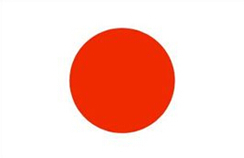
Kyushu Institute of Technology
http://www.kyutech.ac.jp/
Tokoha University
http://www.tokoha-u.ac.jp/
Akita University
http://www.akita-u.ac.jp/honbu/
Kanazawa University
http://www.kanazawa-u.ac.jp/

Canada
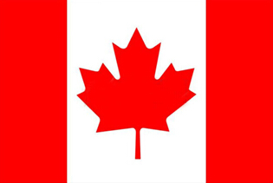
University of Quebec at Chicoutimi
http://www.uqac.ca/
University of Waterloo
https://uwaterloo.ca/

America
Temple University
http://www.temple.edu/
University of Illinois at Chicago
http://www.uic.edu/
George Mason University
http://www.gmu.edu/
Ball State University
http://cms.bsu.edu/
Northern Arizona University
http://www.nau.edu/
University of Nebraska Kearney
http://www.unk.edu/
Troy University
http://www.troy.edu/
Eastern Washington University
University of Nebraska-Lincoin
http://www.ewu.edu/
Lawrence Technological University
http://www.ltu.edu/
University of California, Davis
http://www.ucdavis.edu/
Michigan Technological University
http://www.mtu.edu/
Old Dominion University
http://www.odu.edu/
Bryant University
http://www.bryant.edu/
University of Missouri
http://missouri.edu/
Central Washington University
http://www.cwu.edu/
University of Texas at San Antonio
http://www.utsa.edu/

Australia
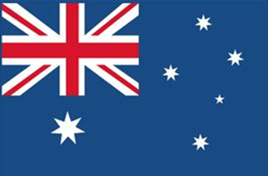
University of Western Sydney
http://www.uws.edu.au/
Griffith University
http://www.griffith.edu.au/
The University of Western Australia
http://www.uwa.edu.au/

