PREMIER LI KEQIANG INSPECTS HEBEI NORMAL UNIVERSITY
Chinese Premier Li Keqiang, also a member of the Standing Committee of the Political Bureau of the Communist Party of China Central Committee, asks about the employment situation of its graduates when he visits Hebei Normal University in Shijiazhuang.
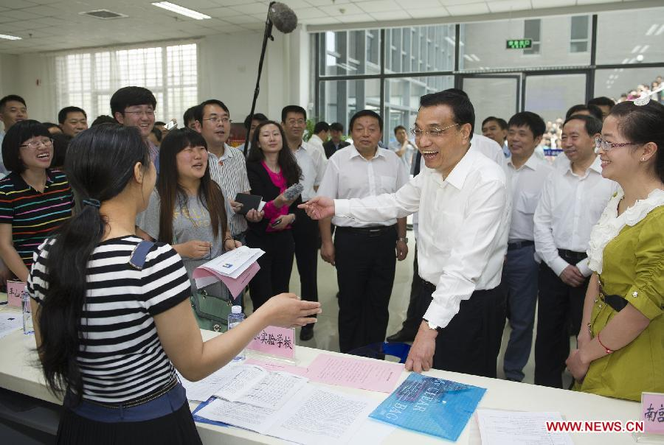
Chinese Premier Li Keqiang, also a member of the Standing Committee of the Political Bureau of the Communist Party of China Central Committee, asks about the employment situation of its graduates when he visits Hebei Normal University in Shijiazhuang, capital of north China's Hebei Province, June 8, 2013. Li paid an inspection tour to Hebei Province from June 7 to 8. [Photo/Xinhua]
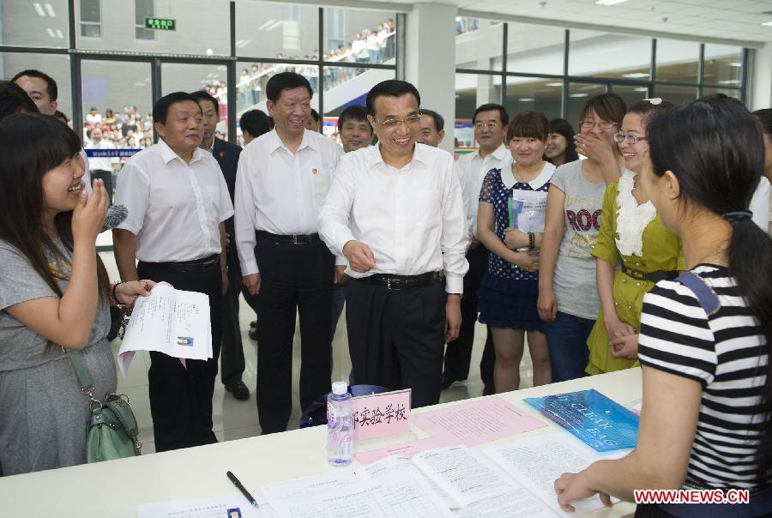
Chinese Premier Li Keqiang, also a member of the Standing Committee of the Political Bureau of the Communist Party of China Central Committee, asks about the employment situation of its graduates when he visits Hebei Normal University in Shijiazhuang, capital of north China's Hebei Province, June 8, 2013. Li paid an inspection tour to Hebei Province from June 7 to 8.

