BHI&EHL
Author:BHI Office Date:March 6,2014
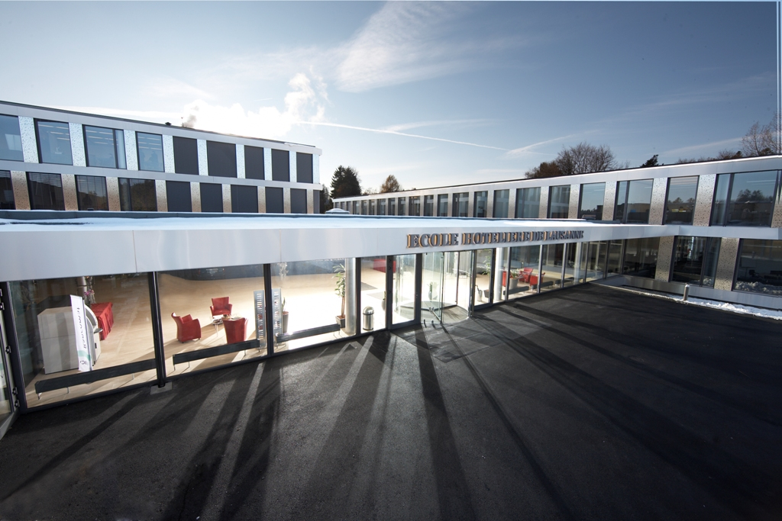
Academic Certification of Ecole hôtelière de Lausanne

BHI is the only educational institution with the Academic Certification of EHL in China. EHL provides BHI with consulting support in the design of program and curriculum, the training and the development of the management and faculty team, academic evaluation on teaching materials and classes.
1. EHL global Academic Certification system: BHI’s program is in accordance with EHL and other 8 Lausanne-certified hotel schools all over the world and established an interscholastic Credit Transfer System

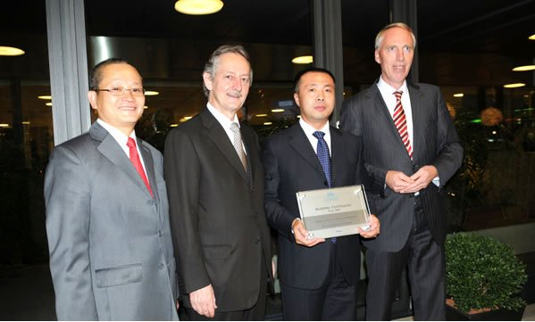
Join in the Academic Certification System of EHL
2. QLF: EHL sends consultant to do the Qualified Learning Facilitator (QLF) training for the teachers in BHI. QLF certificate is a precondition for all teachers in BHI.
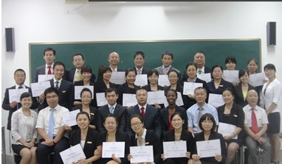
2012 QLF Training
3. Academic Audit: Every year, EHL will send consultants to BHI to do the academic audit to ensure the quality of teaching.
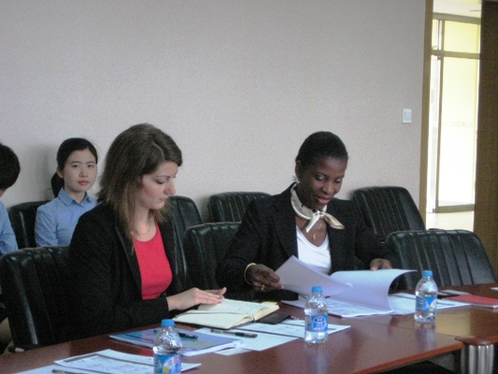
4. BHI teachers will also go to Switzerland to attend the summer and winter training program with hoteliers all over the world in Lausanne to share the latest hotel information.
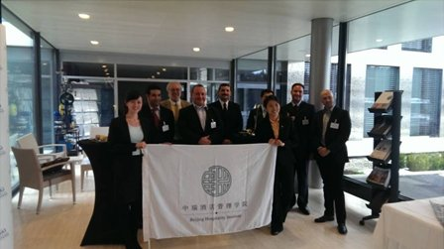

5. All graduates of BHI will get an academic certificate co-sighed by EHL&BHI, which is globally recognized
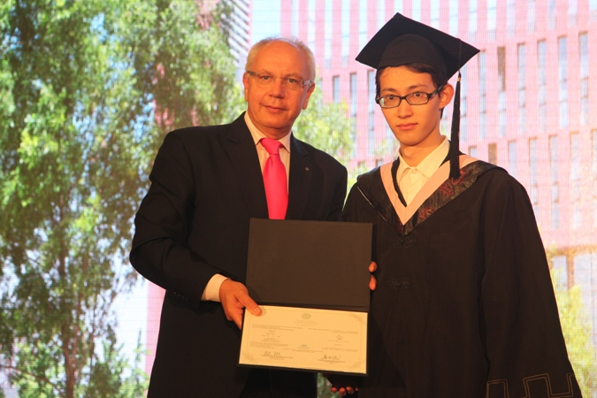
Student get the Certificate from Prof. Michel ROCHAT, General Director of Ecole Hôtelière de Lausanne

6. Students exchanges: BHI students can go to EHL or other certified schools
(1)Transfer: BHI students could apply for transfer to EHL or other certified schools after 5 semesters in BHI with IELTS 7 .When graduate will get the diploma from both EHL and BHI.
Ms Chai Wenting Transfered to EHL in 2013
(2)Semester Abroad: BHI students could apply for semester abroad to EHL or other certified schools after 5 semesters in BHI with IELTS 7 and will get a certificate after study.

(3)Special Program: 2-Week special program in Lausanne and will get a certificate after the program.
Students enjoy the Group work in EHL

