Campus Life
The school's students practice a variety of colorful extra curriculum activities. A two-polar campus culture pattern has been formed which is a series, refined and characterized in specialty. Actively involved in the activities, such as seminar "Challenge Cup" technology contest, Two Hundred Forum seminars, "Civilization and Cultivation" Moral Development, "Shining NENU" Original Art, "Age of Passion" Excellence Exhibition, and Quality of Specialty Competition organized by schools, students have enriched spiritual life, improved over-all qualities, morality in the process and a broad stage for continuing development is provided. At the opening ceremony of the 6th Asia Winter Games, held in the January of 2007, the school successfully undertook theatrical festival, which makes the school the first among all the universities to hold theatrical festival for international sports events. Red Candle volunteer association of NENU, with a nation-wide influence, gained many national awards. It is respectively awarded as one of the "Ten Excellent Volunteer Service Organizations in China", "Advanced Group in Learning from Lei Feng and Volunteer Services", "Advanced Group in Helping the Disabled".
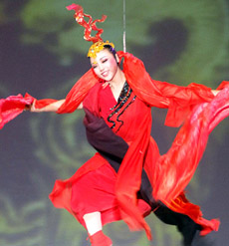 | 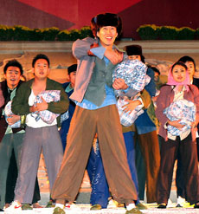
NENU Undertakes Art and Sport Performance at the 6th Opening Ceremony of Asian Winter Games | The Dance-Going to the City Steps into CCTV Spring Festival Gala Evening
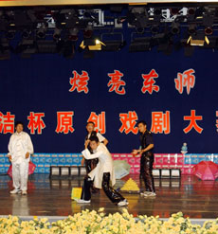 | 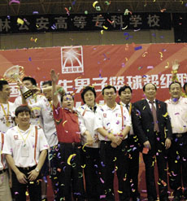
The Basketball Team from NENU Wins the Championship from the 3rd China University Basketball Super League | Undergraduates of NENU hold Original Drama Competition
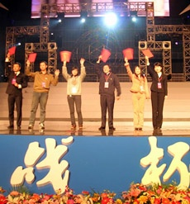 | 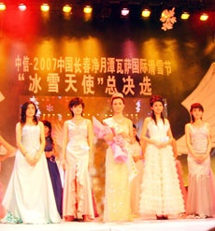
Students from NENU Receive Special Award on the 9th Challenge Cup | A Student from NENU Is Honored "Snow Angel" on International Skiing Festival

